AEROSEM A and ADD: Versatility has a name
With the development of the AEROSEM pneumatic seed drill many years ago, Pöttinger managed to integrate precision seed drilling technology into a standard pneumatic seed drill. Extended many times and continuously improved, AEROSEM A and ADD (double-disc coulter) pneumatic seed drills are suitable for all farms, locations and sowing requirements. Both machines are available with working widths of 3.0, 3.5 and 4.0 metres. For the best seed emergence, Pöttinger offers every farm the right equipment.

Successful sowing begins with the best tools
Successful sowing is dependent on perfectly-matched coulters for opening the seed slot, uniform seed placement and covering the seed again. With its AEROSEM A seed drills, Pöttinger offers exactly the right coulters for different requirements:
The concave single disc coulter with a diameter of 320 mm - opens up the soil and, in combination with a cast coulter point, pushes trash away from the seed slot. Both coulter rows have the same coulter pressure with a maximum of 25 kg. The adjustable rotating scrapers are located behind. They provide plenty of clearance to the side and can handle large clumps of soil.
The DUAL DISC double disc coulter system ensures precision seed placement with linkage-mounted AEROSEM ADD seed drills. The large coulters are slightly offset and form a uniform, clean, V-shaped seed slot. The maintenance-free, equal-length coulter arms ensure maximum reliability. With up to 60 kg applied to each seed coulter, they reliably cut through plant residues even at high driving speeds.

Convenient coulter pressure adjustment
Depth adjustment and coulter pressure adjustment are conveniently carried out from the side of the linkage-mounted AEROSEM seed drills. On the single disc coulters, the depth is adjusted using the coulter pressure, or the optional depth control wheels.
With the DUAL DISC coulter system, the depth is adjusted for the entire machine centrally using two turnbuckles. Coulter arms of equal length ensure uniform coulter pressure across the entire working width, hydraulic adjustment is available as an option for both types of coulter.

The highest metering precision
The AEROSEM metering system is designed for the highest possible precision and ensures that exactly the right flow rate of any given seed type is used, even in the most difficult operating conditions. An outlet flap provides an additional level of fine adjustment depending on the size of the seed.

Short & compact
The compact design of AEROSEM implement-mounted seed drills is possible because the coulter rail and rear roller are so close together. Mounted on a power harrow or compact combination, the centre of gravity is located close to the tractor The AEROSEM is mounted on the rear roller and is guided by a top link. The weight of the seed drill is carried by the rear roller. The roller and seed drill form a compact unit and enable parallel guidance of the machine. This means that when the working depth of the power harrow is changed it does not influence the seed placement depth of the coulters.

PCS (Precision Combi Seeding) for perfect placement
The PCS option integrates precision seed drill technology into a rigid pneumatic seed drill made by Pöttinger so you can operate independently of dedicated precision seed drills. This means more flexibility and more cost effectiveness. With the PCS system on the AEROSEM ADD, the maize seed is placed at 37.5 cm or 75 cm, or in a double row (DUPLEX SEED) with 75 cm row spacing. With DUPLEX SEED, optimum plant distribution density is achieved by doubling the longitudinal spacing when dividing the seeds into two maize rows An increase in yield of up to 5.5 % is possible with silage maize and corn maize.

Feedback from farmers confirms that the wide range of applications and seeding quality of the AEROSEM A and ADD exceed all expectations. Users are very pleased with how well the system works and how straightforward it is to operate. The AEROSEM offers convenience and pure precision for every arable farming professional.

Photo preview:
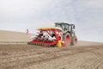 | 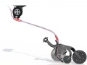 | 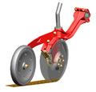
The AEROSEM 3002 ADD for the best seed emergence | The concave single-disc coulter | DUAL AEROSEM DISC double-disc coulters
https://www.poettinger.at/de_at/Newsroom/Pressebild/2736 | https://www.poettinger.at/de_at/Newsroom/Pressebild/2822 | https://www.poettinger.at/de_at/Newsroom/Pressebild/3160
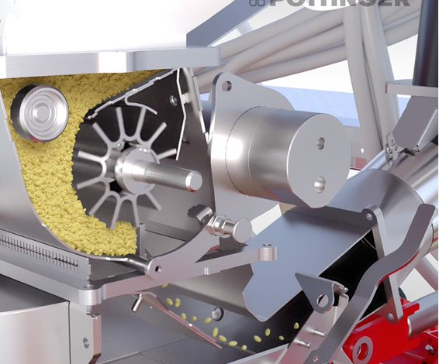 | 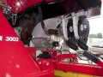 | 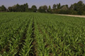
The highest metering precision | PCS for perfect seed placement | Two-row seed emergence with DUPLEX SEED
https://www.poettinger.at/de_at/Newsroom/Pressebild/5175 | https://www.poettinger.at/de_at/Newsroom/Pressebild/2821 | https://www.poettinger.at/de_at/Newsroom/Pressebild/3807

More printer-optimised press photos: http://www.poettinger.at/presse

