Wide range of applications with AMICO F front hopper
Transport large volumes a long way

The new AMICO F front hopper in combination with the TERRIA stubble cultivators offers the possibility to apply fertiliser and sow a cover crop at the same time. The capacity of 1,700 or 2,400 litres and a division of 60:40 ensures a wide range of applications. The hopper is available with one or two metering units for mixing different components.

Highest flexibility
To ensure convenient operation, the AMICO F front hopper is equipped with ISOBUS as standard. The material is applied using a single shoot process with a pressurised hopper system. One or two metering units can be controlled site-specifically by the intelligent control system. Furthermore, the hopper can also be used no problem together with third-party equipment thanks to the ISOBUS control system.

Convenient operation
The metering units are easily accessible from the front, so the metering wheels can be changed quickly. A shut-off plate makes swapping the metering wheels even easier. Calibration can be performed conveniently from the ground using a calibration button. An additional loading platform makes it easier to fill the hopper. A large pressure-tight fitting is provided for emptying residual material.

Transport large volumes a long way
In order to be able to achieve long conveying distances, the AMICO F features a pressurised hopper system. This enables consistently high volumes of seed and fertiliser materials to be mixed and transported. A high level of reliability is also ensured because the seed and fertiliser are transported under pressure.

Versatile application capabilities
- Sowing of a wide variety of cover crops
- Direct fertilisation of the seed as a starter using the Single Shoot process
- Sowing companion crops to control weed growth
- Applying fertiliser deposits in autumn
- Sowing different grass crops such as grass and clover simultaneously.

Photo preview:

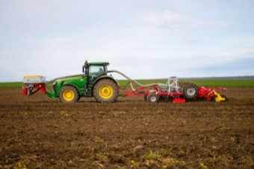 | 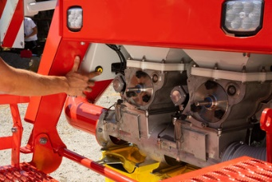
AMICO F front hopper, versatility for all applications and makes | Convenient operation with direct access to the metering units
https://www.poettinger.at/de_at/newsroom/pressebild/41829 | https://www.poettinger.at/de_at/newsroom/pressebild/72160

More printer-optimised photos: http://www.poettinger.at/presse

