Pöttinger Ireland with new location
In 2012 the Austrian agricultural machinery manufacturer Pöttinger founded a sales subsidiary in Ireland. At the original location in Clonmel, the need for additional space could no longer be met due to growth. In addition to sales offices, the new location also offers a spare parts warehouse and a spacious area for product training, both for dealers and end customers. The new Pottinger Ireland Ltd. location was officially opened on 14 January 2020. A delegation from the Austrian headquarters, high-ranking politicians, numerous dealers and persons from the industry were present at the ceremony.

More success with Pöttinger in Ireland
The search for a suitable location was already successful in November 2017. After extensive reconstruction and adaptation measures, work in the new building begun in June 2018. Pöttinger now presents itself accordingly as a premium manufacturer and an attractive employer in the region.
Diarmuid Claridge, General Manager of Poettinger Ireland Ltd. is satisfied with the choice: "Our machines and services enjoy an excellent reputation in Ireland. Demand has been steadily increasing thanks to the efforts of the entire workforce and the marketing effort from Austria. We want to further improve the level of service for our partners and dealers with the new location".

Ceremonial opening
The Austrian delegation, led by Gregor Dietachmayr, Speaker of the Executive Board, Sven Niels, Director Sales, Christoph Stüblreiter, Area Sales Manager, TC Truesdell, Director Marketing Global, Volker Baier, Director Spare Parts Global and Klaus Lindorfer, Area parts manager celebrated the official opening, which will enable the company to continue on its successful path in Ireland. Ambassador Helmut Freudenschuss, Josef Treml from Advantage Austria, FTMTA CEO Gary Ryan and FTMTA President Jimmy Butler, Clonmel town Mayor Gareth Ahearne, and representatives from both FCI and PAC, were among the guests of honor at the event.
Diarmuid Claridge, General Manager of Poettinger Ireland Ltd. is pleased: „It was a particular delight to have so many of our business associates join us in this landmark event, to share in our success.” At the same time he thanked the seven employees for their professional cooperation during the relocation and their extraordinary commitment.

The story of success on the green island
The almost 7 percent increase in turnover in the 2018/2019 financial year compared to the previous year clearly shows the successful development of the Pöttinger subsidiary in Ireland. The top selling products in Ireland are loader wagons and hay machines. The company is focused on further developing the tillage market in Ireland. Products like TERRADISC and SYNKRO are in high demand but as technology is fast developing more farmers are looking to the AEROSEM seed drill for enhanced market leading features like IDS and section control to improve their crop and increase profits.

This new premises in Clonmel is the foundation for Pöttinger’s future growth:
“We have a clear joined vision for the future, and that is to provide the best working results for our customers by developing the best products and services to greater enhance on farm efficiency, productivity, profitability and lifestyle.” comments Diarmuid Claridge on his strategy for the next successful years.

Preview:
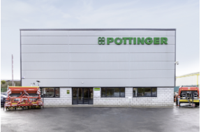 | 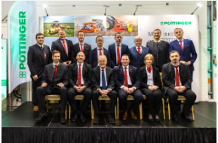 | 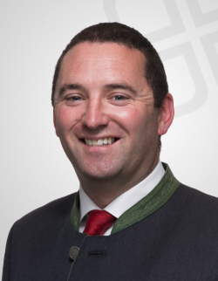
The new location | Opening ceremony in Clonmel | Diarmuid Claridge, General Manager
https://www.poettinger.at/de_at/Newsroom/Pressebild/4464 | https://www.poettinger.at/de_at/Newsroom/Pressebild/4465 | https://www.poettinger.at/de_at/Newsroom/Pressebild/4463

