New TERRASEM with working widths of 8 and 9 metres
Pöttinger makes efficient and high output seed drills
There are many factors involved in sowing: The optimum sowing time depends on the type of plant, the duration of sunshine, and temperature. These weather-dependent time windows are getting shorter and shorter, so efficient, high output drilling is decisive. The new TERRASEM machines from Pöttinger guarantee this with the V 8000 and V 9000 models.

TERRASEM - the new generation
The new trailed seed drills are now also available with working widths of 8 and 9 metres and can be custom-equipped to handle all site-specific conditions. Thanks to the disc harrow as the leading tillage tool, the TERRASEM seed drills are ideal for mulch drilling and are available with WAVE DISC’s as an option for loosening the soil in strips. The CLASSIC version without tillage tools is impressively smooth running on prepared seedbeds. With their large working widths, high operating speeds are possible with the best positioning accuracy.
Convenient operation without crabbing
A new configuration of all tillage tools ensures that the machine works efficiently and 100 percent in a straight line. The disc harrow as well as the fertiliser coulters (D Z-machine) and DUAL DISC seed coulters are mounted in an X configuration. There is no need to grease the tillage tools because they are mounted on sealed bearings.
Metering with the highest precision
The metering systems are designed for the highest possible precision and ensure that exactly the right amount of any given seed type is used. The TERRASEM V 8000 D and TERRASEM V 9000 D are equipped with two metering systems as standard and have a seed hopper capacity of 5,600 litres. Seeding rates of 1.5 kg to 420 kg at 12 kph are possible. The seed flow rate can easily be adjusted on these machines without leaving the tractor seat.
Multiple sowing options
Single shoot, double shoot and double shoot-mix are the key to perfect emergence. Optimised to specific conditions and crop rotations, it is possible to vary between the application of
- seed,
- seed with fertiliser,
- two different mixtures of seed,
- additional components such as microgranules or a companion crop
using the TERRASEM Z models with FERTILIZER feature.

Pöttinger also proves its expertise in the digitisation with the new TERRASEM models by making them agrirouter-compatible.

Photo preview:

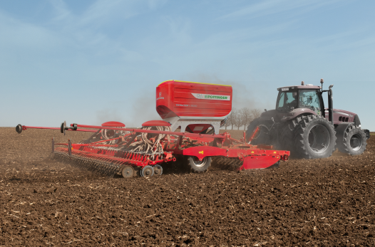
The TERRASEM V 8000 D for efficient, high output drilling
https://www.poettinger.at/de_at/Newsroom/Pressebild/5151

More printer-friendly photos are available at: https://www.poettinger.at/presse

