Poettinger prepared for continued growth in North America: New location officially opened
The European agricultural machinery manufacturer Pöttinger established its own sales subsidiary in the U.S.A. in 2008. The increasing interest in agricultural machinery delivering the best working results and the associated growth necessitated further expansion: a new company location was established in Valparaiso (IN). The grand opening took place on February, 21st 2024 - in the presence of local politicians, dealers and a delegation from the headquarters in Austria.
Focus on North America
The foundation stone for the new building was laid in March 2023 and a 20 acre plot of land - close to the previous location - was purchased. The construction vehicles arrived in mid-June and a building measuring around 19,500 ft² (1,800 m²) was erected. Pöttinger has of course also implemented its high standards of sustainable construction to this new building.
The need for space for parts storage, training and customer service has increased enormously in recent years. The new building is now home to modern offices, showrooms, and a large parts warehouse.
"North America is a critical market for Pöttinger with an already considerable turnover of approximately USD 40 million," says Gregor Dietachmayr, Speaker of the Executive Board, explaining the reasons for the new investment in a highly competitive market. A major advantage of the new sales location on Slover Road in Valparaiso is the existing expansion potential. The large area around the company building offers sufficient space for machine demonstrations and practical training.
The opening ceremony on February, 21st 2024 was attended by various dealers, local politicians and journalists, as well as a high-ranking delegation of company representatives from the company headquarters. Klaus Pöttinger, one of the owners, Gregor Dietachmayr, Speaker of the Executive Board and Andrew Brown, General Manger of Poettinger U.S. and Canada hosted the opening ceremony.

Full speed ahead
Mowers, tedders, rakes and short disc harrows account for the largest share of Pöttinger's sales in North America. There is still great potential for the new merger MERGENTO and seeding technology. As an arable farming specialist, the company has many opportunities to establish itself and make the PÖTTINGER brand even more visible and tangible.
“Our aim is to further expand our service and parts supply while continuing to grow our comprehensive dealer network throughout North America,” says Andrew Brown with conviction. “With the new location, we have expanded our capacities and efficiencies to handle current and future challenges. Our team of 28 employees in North America is motivated to use the new location to showcase their expertise in parts, service, training and consulting,” says General Manager Andrew Brown, pleased with the successful start.

Photo preview:
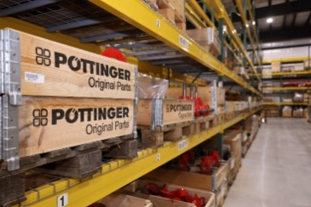 | 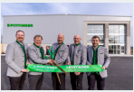
The new, spacious  spare parts store | From the left: TC Truesdell, Klaus Pöttinger, Andrew Brown, Gregor Dietachmayr, Stefan Amering | The festive opening ceremony
https://www.poettinger.at/de_at/newsroom/pressebild/121968 | https://www.poettinger.at/de_at/newsroom/pressebild/121966 | https://www.poettinger.at/de_at/newsroom/pressebild/122186

The guests get a piece of the ribbon | Klaus Pöttinger signs the ribbon | MERGENTO has great potential in North America
https://www.poettinger.at/de_at/newsroom/pressebild/122187 | https://www.poettinger.at/de_at/newsroom/pressebild/122188 | https://www.poettinger.at/de_at/newsroom/pressebild/53552

Further images under: https://www.poettinger.at/presse

New address:
Poettinger U.S. Inc., 2855 Slover Road, Valparaiso, IN 46383

