New SERVO 2000 Compact Hitch-mounted Reversible Plough
Perfect ploughing with Pöttinger

With the introduction of the SERVO 2000 series, arable specialist Pöttinger has given its range of ploughs a complete makeover. The lightweight SERVO 2000 hitch-mounted reversible ploughs now round off the range for compact tractors up to 130 hp. The design of these new ploughs stays true to that of the larger series, the SERVO 3000 and SERVO 4000, adapted to the power requirements.

The SERVO 2000 ploughs are available with 3 to 4 furrows, as well as various underbeam clearances and point-to-point spacings. And with the SERVO 2000 P, Pöttinger presents its first lightweight reversible plough with hydraulic furrow width adjustment. In addition, the SERVO 2000 N features the well-known NOVA hydraulic stone protection. The standard plough is fitted with mechanical stone protection and hydraulic furrow width adjustment.

Intuitive plough set-up
The clearly laid-out and intuitive SERVOMATIC control centre with its four-joint linkage makes it quick and easy to set up the plough correctly. This means the plough can be adjusted for different tractors in just a few steps. The scale makes it easy to set the front furrow width based on the tractor’s inside track width. The preset pulling point ensures that the plough follows the optimum pull line. Adjustments can still be made for particular conditions. When changing the furrow width with the PLUS furrow width adjustment, the pulling point and front furrow width are altered accordingly. The beam angles with beam angle lift are located inside the casing where they are protected from dirt, always ready for use and prevent stress on the turnover unit.

Reliability for the toughest conditions
For tough operating conditions on stony ground the SERVO 2000 is equipped with NOVA hydraulic stone protection. Its hydraulic cylinders are inside the casing and thus perfectly protected from damage. When considering the geometry of the mounting brackets, care was taken to place them near the tractor. To respond to the prevailing conditions, triggering pressure is adjustable from 1,000 to 1,350 kg. With vertical trip clearance of up to 36 cm, the force in the system increases to ensure rapid soil re-entry of the plough share. Side trip clearance is also possible.

The 90 mm diameter turnover shaft, which is designed as a hollow shaft, ensures reliable turnover and a long service life in combination with the generously dimensioned cast-steel turnover unit. The turnover cylinder in the turnover unit has a double-sided lug and is integrated over a large area into the headstock tower via the forged bearing journal. The frame dimensions of 100 x 100 x 10 mm, together with the main beam section, reduced number of holes and the PLUS furrow width adjustment bearing points outside the frame guarantee the greatest possible strength for years of service.

Optimised mounting
The headstock offers a great many adjustment options along with a geometry perfectly designed to match this power class. By adapting the lower linkage points the centre of gravity can be moved as close as possible to the tractor and mounting axle height adjusted. A range of mounting widths is also available. The top link can be mounted in two fixed holes and one slotted hole. The many possibilities for perfect adjustment to the tractor guarantee easy raising and safe operation.

Perfect incorporation
The best working results and a "clean slate" provide the basis for getting the next crop off to a good start. To achieve this, Pöttinger offers mouldboards for every type of soil that have proved their quality for many years and are available in various shapes and materials. A wide range of additional tools such as skimmers and coulters are also available. Pivot depth wheels, dual depth wheels and transport pivot wheels of various sizes can be selected for optimum depth control. The depth wheels are mounted near the frame which ensures optimised ploughing along field boundaries right up to the very edge of the field. This creates a tidy finish and prevents weeds from encroaching into the field from the edges.

The basis of success
With the SERVO 2000, Pöttinger completes the new series of ploughs. Straightforward adaptation of the relevant control parameters with the SERVOMATIC control centre, optimised mounting geometry and a robust construction are the standout features of the SERVO 2000. With the PLUS hydraulic furrow width adjustment these lightweight hitch-mounted reversible ploughs are taken to the next level of comfort and convenience, while the wide variety of implements guarantees perfect working results.

Photo preview:
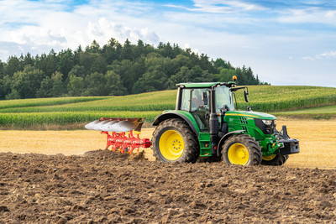 | 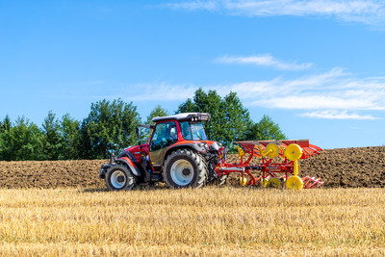
The new SERVO 2000 plough makes the most of its power | Perfect working results with the new SERVO 2000
https://www.poettinger.at/de_at/newsroom/pressebild/155667 | https://www.poettinger.at/de_at/newsroom/pressebild/155553

More printer-optimised photos: http://www.poettinger.at/presse

