Pöttinger: SERVO 4000 Now with
On-Land Ploughing Option
For maximum soil conservation and more user-friendliness

The SERVO 4000 ploughs from Pöttinger, the specialist for the best soil, are being given an additional equipment package for even more operating versatility. The on-land beam link allows travel not only in the furrow, but over unploughed land too.

2 in 1
With the on-land equipment, switching from in-furrow to on-land ploughing with the SERVO 4000 is fast and requires only a few steps. This allows fast reactions to changing conditions. The frame is brought into the on-land position by the leading cylinder. This makes it suitable for use with tractors up to an outside width of 3 m. The swing-out path of the leading cylinder can be adapted to the outside width of the tractor using an adjusting sleeve. This reduces the turning radius and the stress exerted when turning. As on the SERVO 4000 ploughs, the pulling point remains preset, also for travel outside the furrow. The principle and set-up of the SERVOMATIC control centre for the on-land equipment remains unchanged, as does the arrangement of the setting points. Plough set-up remains as straightforward and intuitive as before.

Conserves the soil
The new equipment option allows tractors fitted with wide tyres or crawler tracks to drive on untilled soil. This exerts less pressure on the soil. Because the tyre makes no contact with the worked soil, compaction from the tractor is not pressed into deeper soil layers. Likewise, it eliminates the risk of smearing the bottom of the furrow due to wheel slip from tractors driving in the furrow. Preventing compaction promotes crop root growth, soil life, and ensures access to water and nutrients. This is the basis for a healthy crop and a successful harvest.

Convenience and efficiency
Because the tractor is parallel to the ground when working on land a more comfortable sitting position is guaranteed, as the vehicle does not tilt owing to its tyres being in the furrow. These features provide great relief to drivers, especially on long working days, while at the same time ensuring precise results.

Power without compromise
The SERVO 4000, largest among the mounted ploughs, is designed for maximum output and service life as well as for use with tractors up to 360 hp. The option of on-land ploughing brings greater flexibility for optimum and “made-to-measure” ploughing while at the same time conserving the soil structure.

Photo preview:
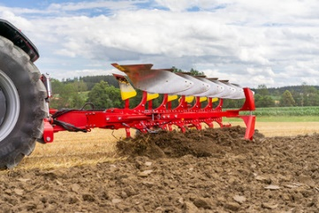 | 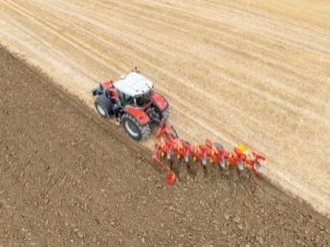
SERVO 4000: for both on-land and in-furrow ploughing | Maximum soil conservation thanks to wide tyres or crawler tracks
https://www.poettinger.at/de_at/newsroom/pressebild/153754 | https://www.poettinger.at/de_at/newsroom/pressebild/153755

More printer-optimised photos: http://www.poettinger.at/presse

