SERVO T 6000 equipped for On-Land ploughing
Pöttinger semi-mounted reversible plough gets out of the furrow and into pure satisfaction

Agricultural machinery manufacturer Pöttinger adds an important feature to the equipment options on the SERVO T 6000. With the On-Land package, the semi-mounted reversible plough for tractors with an output of up to 500 hp gets additional application flexibility. Switching from ploughing in the furrow to ploughing outside the furrow takes just a few simple steps. Soil conservation is enhanced by using tractors with wide tires, dual wheels or crawler tracks for efficient power transmission. However, if this is not possible due to the site conditions, the plough turnover mechanism can also be set for in the furrow if required.

When conditions change, the switch between in-furrow ploughing and On-Land ploughing is done very quickly in a few steps. The hydraulic swing-out On-Land beam link pushes the frame of the SERVO T 6000 outwards so that the plough follows the tractor centrally. This means that it can be used with tractors with an outer width of up to 4 metres, providing plenty of space for dual wheels and crawler tracks. To ensure consistent depth guidance when ploughing outside the furrow, an optional depth wheel provides support in front of the first plough share so it is guided at the precise working depth. This is designed as a space-saving pivot depth wheel within the plough beam. Due to intelligent use of the spool valves, no additional connection is necessary on the tractor for the hydraulic adjustment mechanism.

Conserves the soil
Large tractors are often fitted with wide tyres or dual wheels, this results in not enough space in the plough furrow and driving over ploughed ground is sometimes unavoidable. This is where the SERVO T 6000 with the On-Land equipment option comes in, because the tractor drives outside the furrow on the ground that has not been ploughed. This not only improves the tractor's power transmission to the ground, but also conserves the soil due to the large contact area of the tractor and minimises harmful compaction in deeper soil layers. Likewise, it eliminates the risk of smearing the bottom of the furrow due to wheel slip from tractors driving in the furrow. Preventing compaction promotes crop root growth, soil life, and ensures access to water and nutrients. This is the basis for a healthy crop and a successful harvest.

Efficient and convenient operation
Driving outside the furrow while ploughing ensures a straight pull line, this results in more efficient power transfer from the tractor to the plough and less side pull, reducing wear on the landside. Guidance systems can be used for increased convenience, which ensures precise work and reduces driver fatigue. In addition, the tractor is level with the ground due to no wheels driving in the furrow, ensuring a straight and more ergonomic sitting position for the driver, which is especially important on long working days.

A strong partner
The Pöttinger SERVO T 6000 is designed for use with powerful tractors up to 500 hp. The ability to plough with the On-Land option makes even better use of the available tractor power. This ensures efficient ploughing and reliable power transmission even in difficult conditions. This system is designed for years of professional operation.

Photo preview:
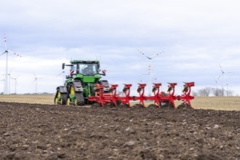 | 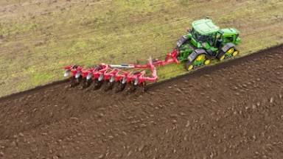
Conserving the soil by plough On-Land with the SERVO T 6000 | Straight pull line when ploughing outside the furrow
https://www.poettinger.at/de_at/newsroom/pressebild/90449 | https://www.poettinger.at/de_at/newsroom/pressebild/90447

More printer-optimised photos: http://www.poettinger.at/presse

